TEMPERATURE MEASUREMENT
Introduction
Temperature is one of the most frequently measured parameters, and with good reason. Temperature serves as an important indicator of the condition of an object in machinery, medical diagnostics, quality control, etc. There are many different methods for measuring temperature, including using infrared and optical fibre technology.
Infrared has been used successfully for many years in many fields, but infrared thermometry is a relatively new concept promising to reduce cost and increase reliability in temperature measurements across a wide variety of consumer and industrial applications.
Some of the advantages of infrared thermometers include:
- Fast responsiveness that enables developers to collect more information per time period.
- Able to measure the temperature of objects that move, rotates, or vibrates.
- Measure high temperatures (above 1500°C) in applications where contact probes will not work or have a short lifetime.
- Do not mechanically damage or contaminate the surface (painted surfaces, food, and soft plastic) of measurement.
- Do not influence the object of measurement, hence it can measure temperature in all objects such as objects with high thermal conductivity where object temperature would change if contacted (glass, wood, small, or very thin objects).
- Measures actual product being manufactured instead of another part of the process.
- Can measure the temperature of hazardous or inaccessible objects where the use of conventional thermometers is impractical.
- Accuracy is comparable with conventional thermometers
Infrared Temperature Sensor
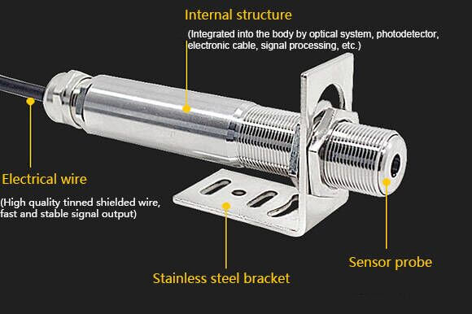
Infrared temperature sensor
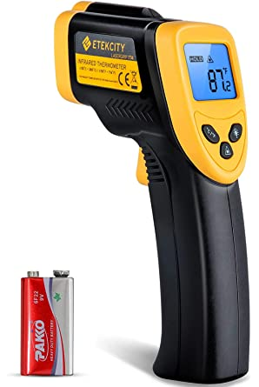
Infrared Thermometer (Digital temperature gun)
An infrared temperature probe or sensor measures temperature by detecting the infrared energy emitted by all materials which are at temperatures above absolute zero, (0°Kelvin).
The most basic design consists of a lens to focus the infrared (IR) energy on to a detector, which converts the energy to an electrical signal that can be displayed in units of temperature after being compensated for ambient temperature variation.
This configuration facilitates temperature measurement from a distance without contact with the object to be measured. As such, the infrared temperature sensor is useful for measuring temperature under circumstances where thermocouples or other probe type sensors cannot be used or do not produce accurate data for a variety of reasons.
Some typical circumstances are where the object to be measured is moving; where the object is surrounded by an EM-field, as in induction heating; where the object is contained in a vacuum or other controlled atmosphere; or in applications where a fast response is required.
Working Principles of infrared Temperature sensor
Each body with a temperature above the absolute zero (-273.15°C =0 Kelvin) emits an electromagnetic radiation from its surface, which is proportional to its intrinsic temperature.
A part of this so-called intrinsic radiation is infrared radiation (Infrared is that portion of the electromagnetic spectrum that lies beyond the visible (blue to red, 0.4-0.75 um) response of the human eye), which can be used to measure a body’s temperature. This radiation penetrates the atmosphere.
With the help of a lens (input optics) the beams are focused on a detector element, which generates an electrical signal proportional to the radiation. The signal is amplified and, using successive digital signal processing, is transformed into an output signal proportional to the object temperature. The measuring value may be shown in a display or released as analogue output signal, which supports an easy connection to control systems of the process management.
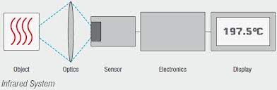

Block Diagram of Infrared Thermometer
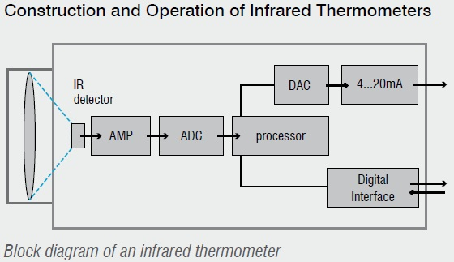
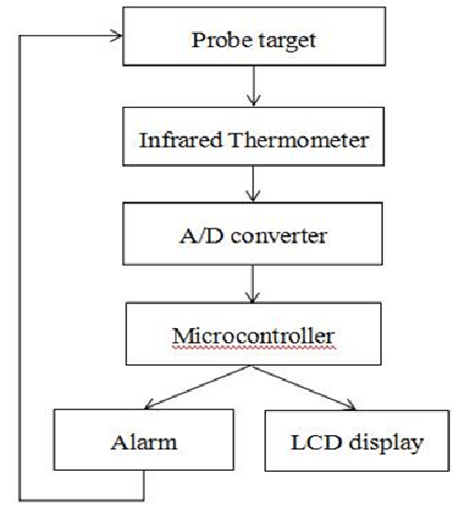
With the help of input optics the emitted object radiation is focused onto an infrared detector. The detector generates a corresponding electrical signal which then is amplified and may be used for further processing.
Digital signal processing transforms the signal into an output value proportional to the object temperature. The temperature result is either shown on a display or may be used as analog signal for further processing. In order to compensate influences from the surroundings a second detector catches the temperature of the measuring device and of his optical channel, respectively.
Consequently, the temperature of the measuring object is mainly generated in three steps:
- Transformation of the received infrared radiation into an electrical signal.
- Compensation of background radiation from thermometer and object.
- Linearization and output of temperature information.
New products apply a technology which uses two-lens optics: Similar to digital cameras, the inner lens position can be switched digitally into focusing onto very small spot sizes. The result is a very small spot size, but only at a constant distance.
If the distance grows smaller or longer between measuring spot and infrared thermometer, the measuring spot increases in size.
Two laser beams crossing each other create a laser point diameter of 1 mm at the smallest spot size position. They help to show optimal distance as well as spot size. The illustration shows the optical system of a modern infrared thermometer: The lens position is selectable and simultaneously various laser sighting systems support a real size display of the measuring spot.

